The Psychology of Premium Websites

Intro
0:00
We've all felt it. You land on a website
0:02
and within seconds you just know it's
0:04
premium. It's not just one specific
0:06
thing you can point to. It's a feeling.
0:08
That sense of quality, trust, and
0:10
authority. But what if I told you that
0:12
feeling [music] isn't an accident and
0:14
instead is a deliberate result of
0:16
applied psychology. Recently, I made a
0:18
video explaining the what. But today,
0:20
we're going deeper. I'm going to reveal
0:22
the three core psychological principles
0:24
that separate cheap feeling websites
0:26
from premium ones. show you how the
0:28
world's top brands use them and give you
0:30
a framework to apply them to your own
0:32
site. The first and most important
Principle #1 The Halo Effect (First Impressions)
0:34
principle is all about first
0:36
impressions. Studies have shown that it
0:38
takes a fraction of a second, about 50
0:40
milliseconds, for a user to form an
0:42
opinion about your website. And that
0:44
opinion determines whether someone will
0:46
stay or whether they'll leave. This is
0:48
driven by a cognitive bias called the
0:50
halo effect. Now, the halo effect is our
0:52
brain's tendency to let our initial
0:54
impression of something color our
0:55
judgment of everything that follows. If
0:58
the first thing a visitor sees on your
1:00
site looks professional, clean, and high
1:02
quality, then their brain automatically
1:04
assumes that your products, your
1:05
services, and your company as a whole
1:08
are equally high quality. And that is
1:10
why the top part of your homepage, the
1:12
hero section, that part you see without
1:14
scrolling, is the most important real
1:17
estate on your entire website. a cheap-l
1:19
looking header, a cluttered layout, or
1:22
quality imagery in that first view. It
1:24
creates a negative halo. Even if the
1:26
rest of your site's brilliant, the
1:28
visitor is now looking at it through a
1:30
lens of skepticism. Premium brands are
1:33
masters of the positive halo. They don't
1:35
just design a homepage. They engineer
1:38
that first impression. Principle number
Principle #2 Cognitive Load & Cognitive Fluency
1:40
two is about making things easy. The
1:42
truth is that our brains are inherently
1:44
lazy. They're designed to conserve
1:46
energy. And when they're faced with
1:48
something that's confusing or hard to
1:50
understand, the brain has to work
1:52
harder. This is called cognitive load. A
1:55
website that creates a high cognitive
1:56
load feels stressful and unprofessional.
1:59
A website that is simple, clear, and
2:01
intuitive creates what psychologists
2:03
call cognitive fluency. It's easy to
2:06
process. Our brains interpret things
2:08
that are easy to process as being
2:10
better, more trustworthy, and of a
2:12
higher quality. Think about it. A
2:14
cheap-looking website is often a chaotic
2:17
mess of competing elements. Your brain
2:19
doesn't know where to look and it feels
2:21
overwhelmed. A premium website on the
2:23
other hand is a masterclass in clarity.
2:26
It uses whites space generously to give
2:28
content room to breathe. It has clear
2:30
visual hierarchy guiding your eye
2:33
exactly where it needs to go. The
2:35
navigation is simple and predictable.
2:37
But there's a very important distinction
2:39
that you need to understand. And this
2:41
isn't just about aesthetics. It's about
2:43
psychology. And by reducing the mental
2:45
effort required to use a site, premium
2:48
brands make you feel calm. They make you
2:50
feel in control. And they make you feel
2:53
confident in their professionalism. The
Principle #3 Micro Interactions & The Peak-End Rule
2:55
third principle is where the real magic
2:57
happens. And it's about those tiny
2:59
details. I'm talking about micro
3:01
interactions. These are the small, often
3:03
quite subtle animations and feedback
3:05
loops that happen when you interact with
3:07
a site. A button that subtly changes
3:10
color when you hover over it. a form
3:12
field that gives you a gentle
3:13
confirmation when you fill it out
3:15
correctly, a smooth transition as you
3:17
scroll down the page. These might seem
3:19
insignificant, but they have a huge
3:21
psychological impact because of
3:23
something called the peak end rule. This
3:25
rule states that people don't remember
3:27
an experience as an average of every
3:29
single moment. They remember its most
3:31
intense points, the peaks, and how it
3:34
ended. Micro interactions are designed
3:37
to create small peaks of positive
3:39
emotion that satisfying click, a smooth
3:42
animation, a helpful piece of feedback.
3:44
These are the moments that spark joy for
3:46
the user. Cheap websites are static and
3:50
lifeless. They do the absolute bare
3:52
minimum, sometimes even less, to be
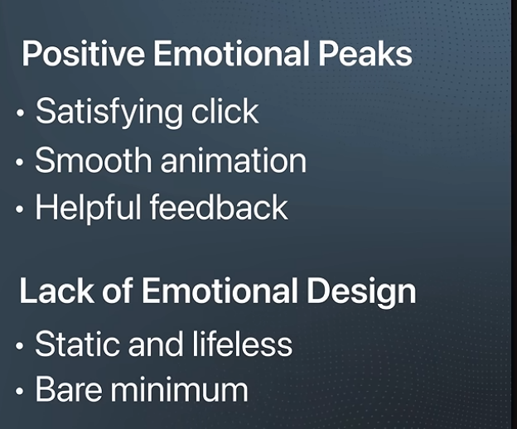
3:54
honest. Premium websites feel alive
3:57
because they're full of these thoughtful
3:59
little details. They signal that the
4:01
creator cared. They cared about the
4:03
users's experience enough to obsess over
4:06
the smallest moments. And when these
4:08
moments are sprinkled throughout your
4:09
website, they add up to create a
4:12
powerful overall feeling of quality and
4:14
craftsmanship. All right, so let's look
How Top Brands Apply This Psychology
4:16
at how the best brands in the world
4:18
apply these principles. First, Apple.
Apple Example (Premium Simplicity)
4:21
They are the masters of the halo effect.
4:24
You land on their site and you're
4:25
greeted with a stunning fullcreen
4:27
product shot and a single bold headline.
4:30
It's minimalist, it's confident, and it
4:32
immediately signals premium. Their
4:34
cognitive load is near zero. It's
4:36
impossible to be confused on Apple's
4:38
website. And their micro interactions,
4:40
from the way the pages scroll to the way
4:42
the menus open, are famously smooth and
4:44
satisfying. Now, let's look at a luxury
Luxury Brands & White Space Strategy
4:46
fashion brand like Hermes or Beta
4:49
Venita. They use extreme white space to
4:51
create a feeling of exclusivity and
4:54
calm. This isn't empty space. It's a
4:56
psychological cue that says, "We are so
4:59
confident, we don't need to shout." They
5:01
reduce the cognitive load to an absolute
5:04
minimum, focusing your attention only on
5:06
their beautiful products. Finally, look
Stripe & Figma (Clarity for Complex Products)
5:09
at a top tier software company like
5:11
Stripe or like Figma. Their sites create
5:14
a powerful halo effect of innovation and
5:16
trustworthiness. They use clear, logical
5:18
layouts to reduce cognitive load and
5:21
make their complex products feel simple
5:23
and approachable. All of these brands
5:25
understand that their website isn't just
5:27
a brochure. In reality, it's more of a a
5:29
psychological experience. So, how do you
3-Step Framework to Make Your Site Premium
5:32
actually apply all of this? Here's a
5:34
simple three-step framework that you can
5:36
use to make your website feel more
5:38
premium as soon as today. Step one,
Step 1 Engineer the First Impression
5:41
engineer your first impression. Don't
5:43
just design your homepage. Obsess over
5:45
the top half of it. Ask yourself, what
5:48
is the single feeling that I want a
5:50
visitor to have in the first 50
5:52
milliseconds? Is it calm? Is it
5:54
confidence? Is it excitement? Build your
5:57
entire hero section around creating a
6:00
powerful positive halo effect. Then step
Step 2 Reduce Cognitive Load
6:02
two, declare war on cognitive load. Go
6:06
through every single page of your site
6:08
and ask, "What can I remove? How can I
6:11
simplify my navigation?" Increase your
6:13
white space. Create a visual hierarchy
6:16
with one primary goal for each section.
6:18
Make clarity your number one priority.
6:21
Remember, what feels simple to you might
6:24
still be confusing to a first-time
6:25
visitor. Step three, hunt for micro
Step 3 Add Micro Interactions
6:28
interaction opportunities. Look for
6:31
every single place that you can add a
6:33
small moment of delight on your website.
6:35
How do your buttons feel when a user
6:38
hovers over them? What happens when a
6:39
page loads? How does your site respond
6:42
as you scroll? These details aren't
6:45
extras. They are the very essence of a
6:48
premium experience, and they show that
6:50
you care. The psychology of a premium
Final Takeaway & Next Steps
6:52
website isn't based on using tricks or
6:55
manipulation or any of that. It's based
6:57
on respect. It's all about respecting
6:59
the visitors time by being clear and
7:02
simple. It's about respecting their
7:04
intelligence by providing a thoughtful,
7:06
well-crafted experience. And it's about
7:08
respecting their emotional response by
7:11
creating moments of delight. If you want
7:13
to learn more about how you can do this
7:15
yourself, click here to watch the next
7:17
video where I walk you through exactly
7:20
how to build a website so premium that
7:23
people will be begging you to buy no
7:25
matter what you

